DBQ – Emperor Justinian

Answer the Document Based Questions on a separate sheet of paper using information from the sources.

Document Collection A

Introduction: Below are two quotes about Emperor Justinian by his official court historian, Procopius. One is written in his official account and the other is written from his Secret History.

Source A1 – Official Court History, Procopius
It is, indeed, a proof of the esteem with which God regarded the Emperor, that He furnished him with men who would be so useful in effecting his designs, and we are compelled to admire the intelligence of the Emperor, in being able to choose the most suitable of mankind to carry out the noblest of his works.

Source A2 – The Secret Histories, Procopius
That Justinian was not a man, but a demon, as I have said, in human form, one might prove by considering the enormity of the evils he brought upon mankind. For in the monstrousness of his actions the power of a fiend is manifest. Certainly an accurate reckoning of all those whom he destroyed would be impossible, I think, for anyone but God to make.

- Which quote do you think is taken from Procopius' Secret History? Give evidence from the quote to support this claim.
- How is Justinian described in Quote 1 by Procopius?
- How is Justinian described in Quote 2 by Procopius?

Document Collection B

Introduction: Justinian I Ruled the Byzantine Empire from 527 to 565 C.E. (A.D.). When he became emperor, the laws of the crumbled Roman Empire in the West were very disorganized and sometimes contradicted each other. Lawyers often took advantage of this confusion by using long-forgotten laws to support their cases. Justinian knew that a clear and fair legal code was necessary to a unified empire. He therefore appointed a commission of ten experts who created a new code of 4,652 laws. These laws were written (by hand, of course) in 50 books, which were further simplified into a single text called The Institutes. Together, these writings are called Justinian’s Code. The Code dealt with everything from property rights to punishments for religious heresy (crimes). Historians credit Justinian’s Code with shaping our basic ideas about law a justice today.

Source B1 – The Institutes of Justinian’s Code, 531 C.E.

Justice is the constant and perpetual [continuous] wish to render everyone his due…the maxims [main guidelines] of law are these: to live honestly, to hurt no one, to everyone his due.

Source B2 – The Second Treatise of Civil Government, John Locke, 1690

The state of nature…teaches all mankind, who will but consult it, that being equal and independent, no one ought to harm another in his life, health, liberty, or possessions.

Source B3 – The Declaration of Independence, Thomas Jefferson, 1776

We hold these truths to be self-evident, that all men are created equal, that they are endowed by their Creator with certain unalienable rights, that among these are Life, Liberty, and the Pursuit of Happiness.

- Why did Justinian create a new legal code for the Byzantine Empire?
- According to The Institutes, what are the three main guidelines one should follow when writing laws?
- What is the meaning of “to everyone his due”?
- What evidence is there that the English philosopher John Locke might have borrowed some ideas from Justinian’s Code?
- According to the Declaration of Independence, what are three unalienable rights that people have? Are any of these rights similar to ideas in the Code? Explain.

Document Collection C

Introduction: In A.D. 528 the Emperor Justinian began a review of the old Roman laws. There were thousands of Roman laws that ordered life in the empire. The emperor chose ten men to review 1,600 books full of Roman Law and create a simpler legal code. These men were able to create the Justinian Code with just over 4,000 laws.

Read these two laws from the Justinian Code. Think about what they tell you about the Roman and Byzantine empires. Answer the questions that follow the samples.

Source C1 – Book I, Of Persons

VIII. Slaves: Slaves are in the power of masters, a power derived from the law of nations: for among all nations it may be remarked that masters have the power of life and death over their slaves, and that everything acquired by the slave is acquired for the master.

Source C2 – Book II, Of Things

I. Division of Things: If the wheat of Titius is mixed with yours, when this takes place by mutual consent, the mixed heap belongs to you in common because each body, that is, each grain, which before was the property of one or other of you, has by your mutual consent been made your common property; but, if the intermixture were accidental, or made by Titius without your consent, the mixed wheat does not then belong to you both in common; because the grains still remain distinct, and retain their proper substance. ...if either of you keep the whole quantity of mixed wheat, the other has a real action [claim or suit] for the amount of wheat belonging to him, but it is in the province of the judge to estimate the quality of the wheat belonging to each.

- Justinian’s Code has four different parts called books. What books do you see here?
- What does the first source tell you about slavery in both empires? How do you think slaves were treated?
- Review The Division of Things. Under this law, what happens if someone takes your property without your permission?
- How do you think this law helped the government maintain order?
- Why do you think it was important for the Roman and Byzantine empires to have extensive legal codes?

Document Collection D

Source D1 – Map of the Byzantine Empire at the beginning and end of Justinian’s reign
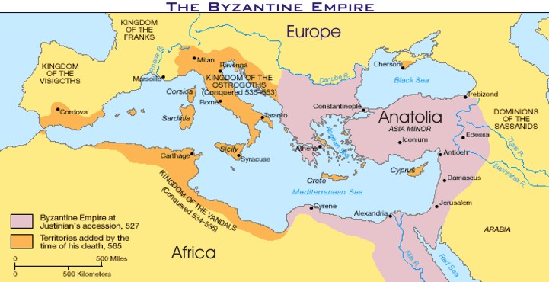

Source D2 – Map of the Roman Empire
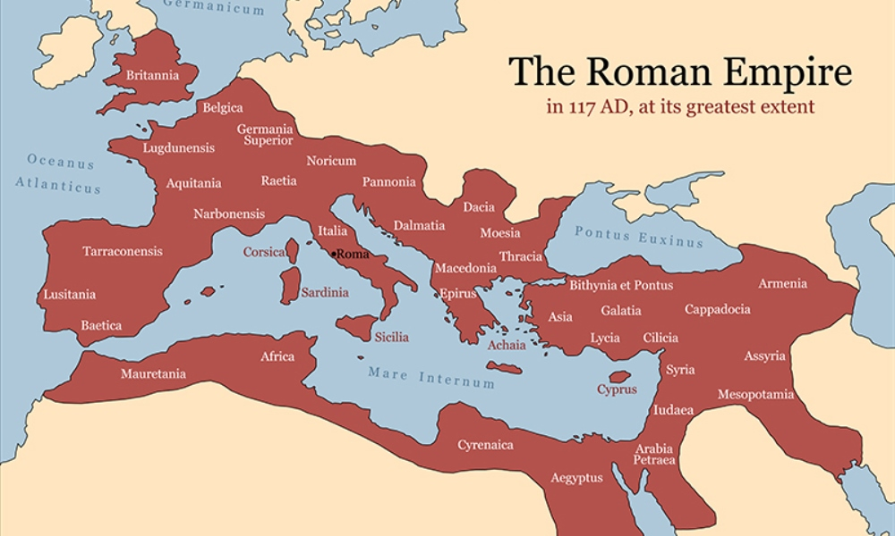

- Using the map of the Byzantine Empire, what was Justinian’s affect on the size of the empire?
- Comparing the two maps, how would you describe the lands that Justinian conquered?

